**Youtube widget**

**Manual Installation**

1. Copy **com.temenos.widgets.youtube** folder in your widgets folder (Ex: /{your project/templates })
2. Restart IDE.

**Auto-Installation**

1. Run IDE.
2. Make sure the “**Switch Monitor on/off**” is checked.
3. Download/ Copy the widget (**com.temenos.widgets.youtube.zip**) to monitored folder.

(**Tools** menu, **Options**, **Auto-install** tab and set in “**Download Location**” the folder where you copied the widgets.) No need to restart IDE.

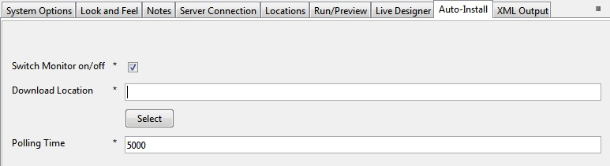

**Overview**

The **Youtube** widget allows users to share uploaded videos from Youtube within a website.

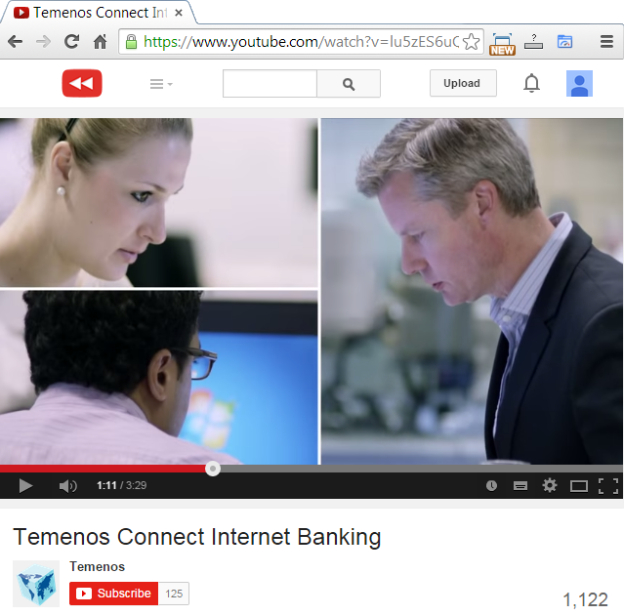

1. You have to insert a new display Item of **Youtube** type in the **Presentation Editor**.
2. Within the Widget Details tab you have to set up the widget settings.
   * **VideoID** – the identifier of your Youtube video. To obtain the ID of a video you need to follow the next steps:

- Go to Youtube search and click on the video that you want to share;

- Copy the video id from address bar of your browser;

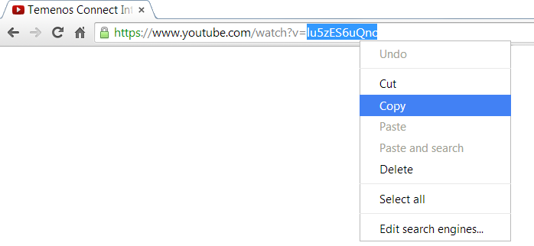

- Paste the id into the input field of the VideoID.

* **Width** – the width of the Youtube frame. Default value is **640**;
* **Height** – the height of the Youtube frame. Default value is **390**;
* **Autoplay** – check this box if you want the video to autoplay when the page loads. Default is **unchecked**;
* **Full Screen** – check this box if you want to see the fullscreen buton ar the end of the control bar. Default is **checked**;
* **Related Videos** – check this box if you want to see related videos at the end of the video. Default is **unchecked**;
* **Show Controls** – check this box if you want to see the controls bar for the video ar the bottom of the video. Default is **checked**;
* **Theme** – select what type of theme (dark/light) do you want your video player to adopt. Default is **dark**.
* **Show Info** – check this box if you want to see the video title and the uploaders name. Default is **unchecked**.

